**Features of selenium**

Selenium – Selenium is an automation tool which works in only browser level.

Selenium IDE – It is an extension which can be downloaded. It is used record the tests (i.e. navigating through webpages). Also helps in debugging tests. It is also used to autofill CSS and xpath values.

* Supports any operating system as is browser level tool
* Selenium is an open source tool
* Supports multiple browsers
* Export and import the tests from one operating system or browser to another one with ease
* Supports multiple languages like java, python, ruby, C#.
* 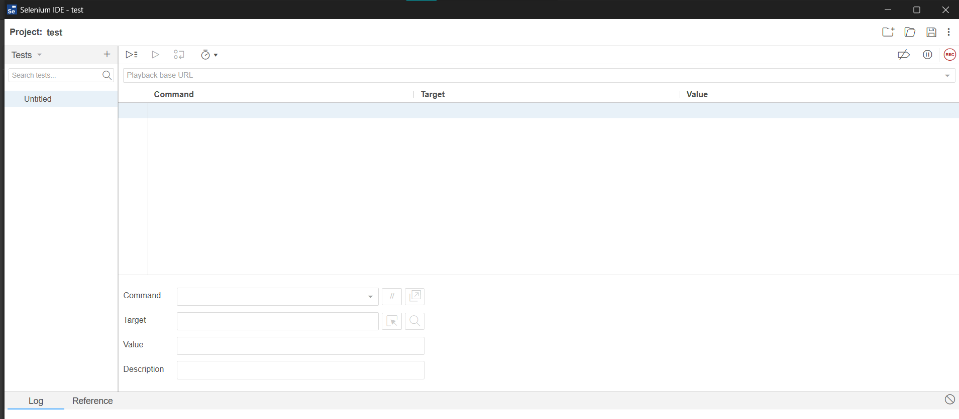The overview of selenium looks like
* Here we can create multiple tests and can combine different tests into a single test suie.